Barrow Residents

Action Group

Which do you prefer?
 2007 OR 2010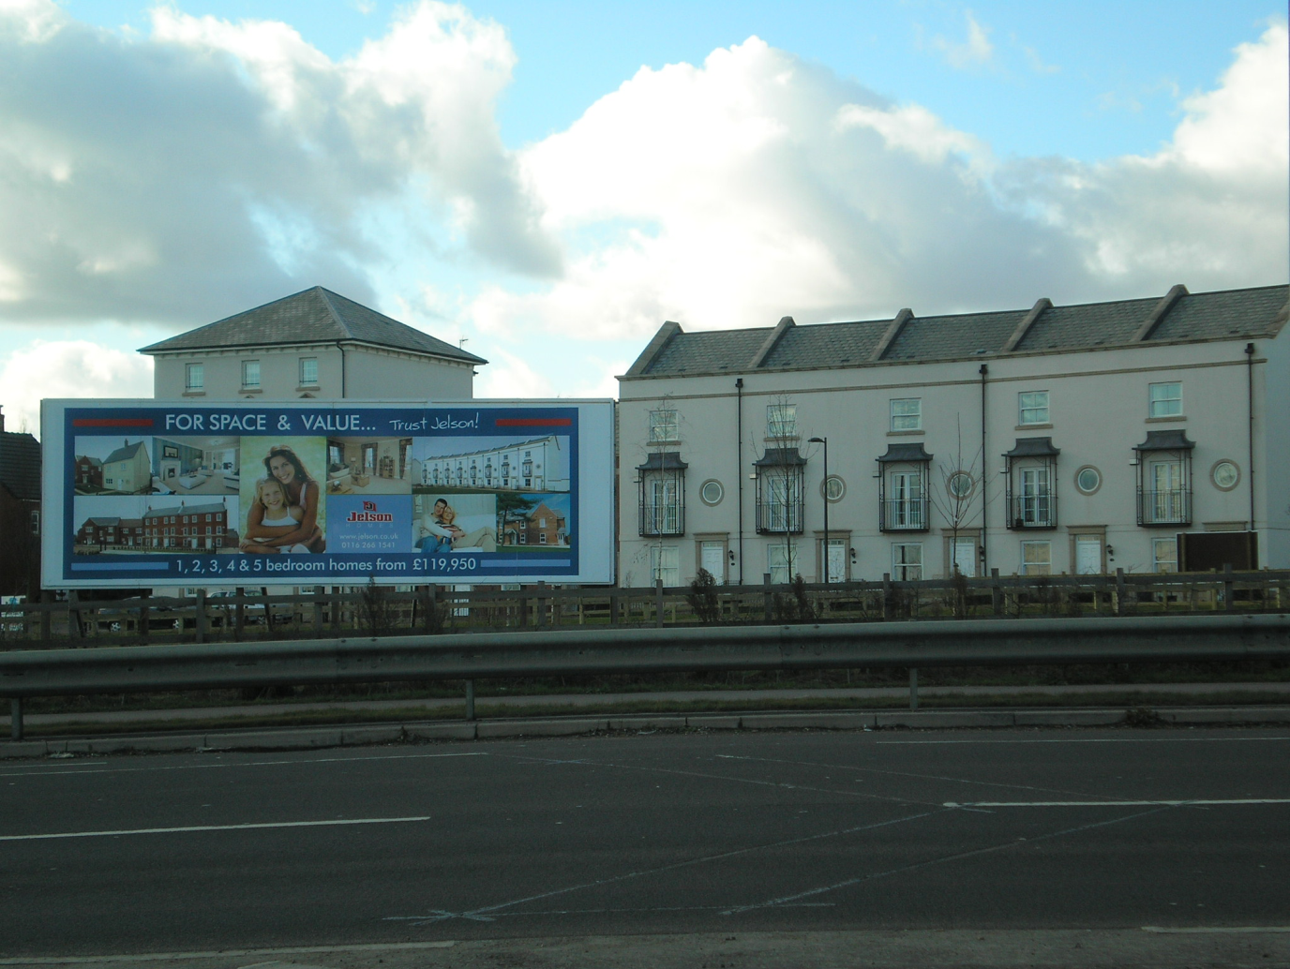
Public meeting to be held at Methodist Church Hall, Wednesday 17th February 7.30pm.
B.R.A.G. and the residents of Barrow Upon Soar object to Jelsons proposal to build 280 houses on green belt land behind Breachfield Road because it would:
- Cause a major increase in traffic flow through an already congested village.
- Further increase the risk of major flooding of Fishpool Brook particularly along Breachfield Road, Sileby Road & Avon Road estate.
- Increase pressure on schools & doctors which are already heading towards maximum capacity.
- Be built on greenbelt land & is outside of the local plan, as admitted by the Charnwood Borough Council.
- Disturb an area inhabited by badgers & kingfishers & is also of geological & archaeological interest.
Please bring with you any further information, photographs of recent flooding or maps of mining/historical interest that we may reproduce to help us against this development.

Contact; B.R.A.G. Secretary Kevin Blood, call: 01509 414094
Email; kevinblood@talktalk.net

Chair: Sandie Forrest Vice-Chair: Alan Willcocks 01509 412477 01509 413996

